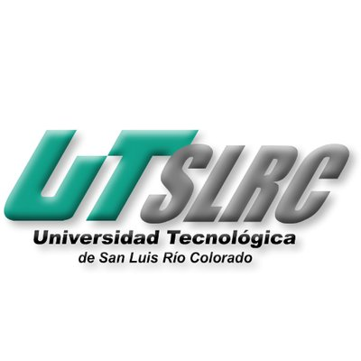

**UNIVERSIDAD TECNOLÓGICA DE**

**SAN LUIS RIO COLORADO**

**REACTIVO PARCIAL III**

**MTRO. RICARDO ALEJANDRO SOTO MORALES**

**AUTOR(ES):**

*GALVAN COVARRUBIAS VICTOR MANUEL*

*MEZA ALVAREZ JUAN*

*PARRA SANCHEZ LESTAT*

*VEGA SAUCEDA ALAN GUADALUPE*

San Luis Rio Colorado, Sonora Agosto, 2020

<https://youtu.be/qfVqacUKwtk>

**What is XP?**

Is an agile software development framework that aims to produce higher quality software, and higher quality of life for the development team.

Its main pillar is to enhance the interpersonal relationships of the development team.

It is the ideal working method for projects with highly changing and imprecise requirements.

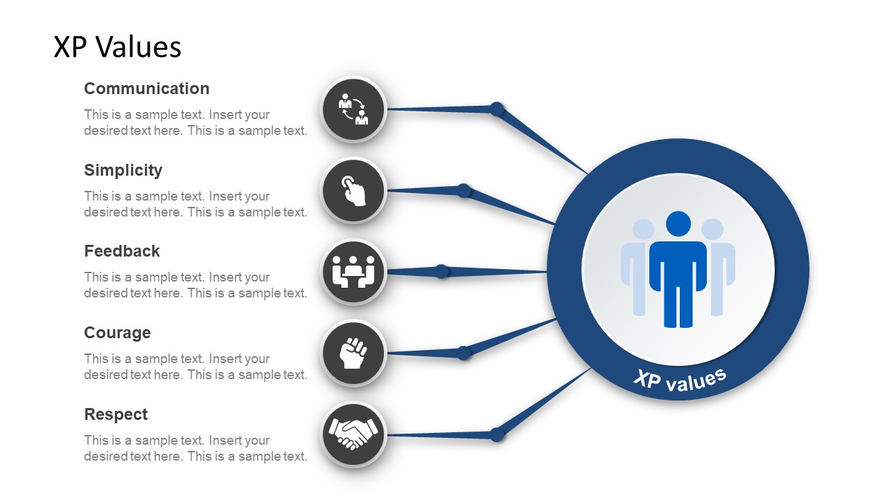**XP values**

Communication

Simplicity

Feedback

Courage

Respect

**Roles**

The Customer

The Developer

The Tracker

The Coach

**Structure**

Pair programming

Code review

Unit testing

Planning game

Courage

Respect

**XP** **process**

